# David Burnett – E15 – I&T Evidence

# REF I.T 1

Encapsulation

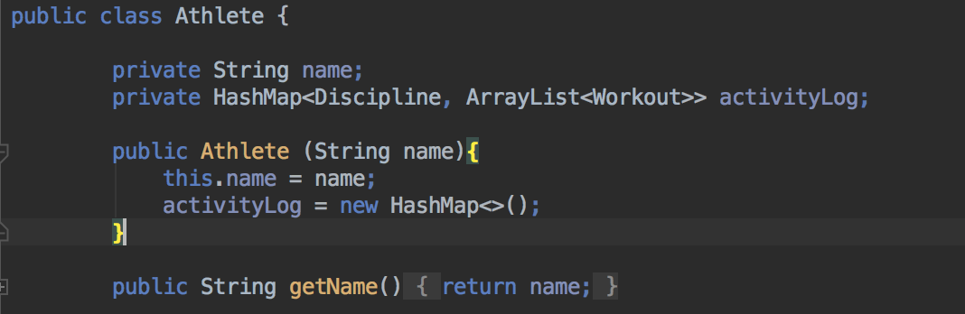

# REF I.T 2

Super Class

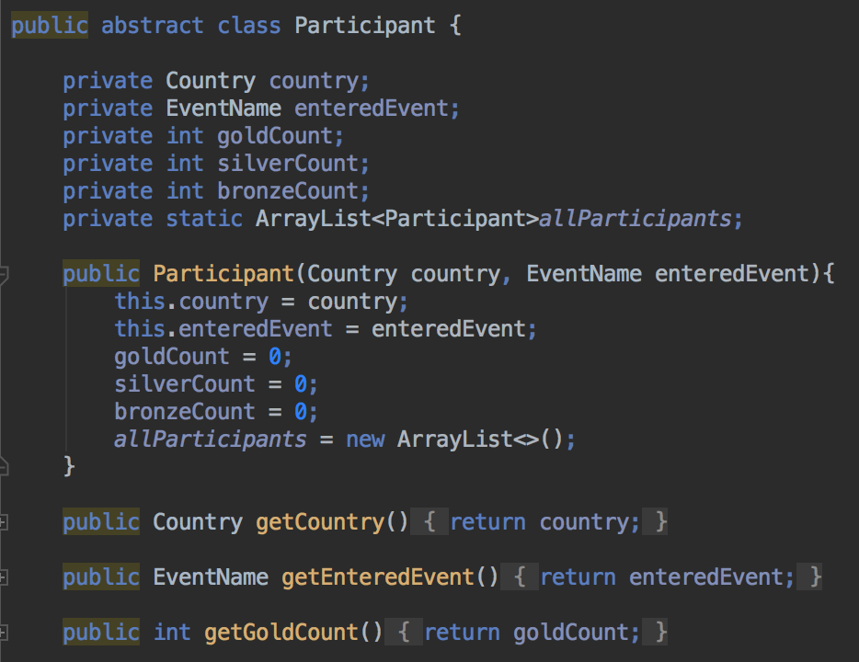

Inherited Class

getTeamGoldMedals() retrieves the goldCount from the superclass.



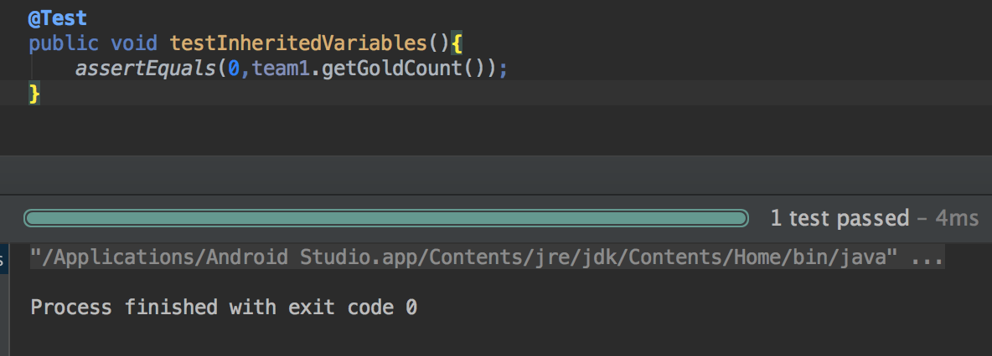

# REF I.T 3

*Input*

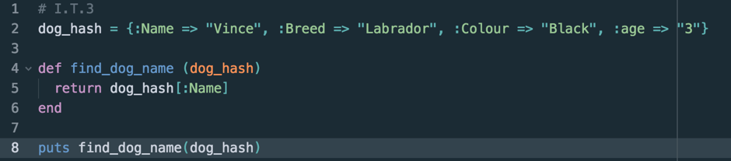

*Output*

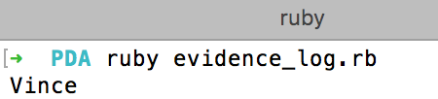

# REF I.T 4

***Input***

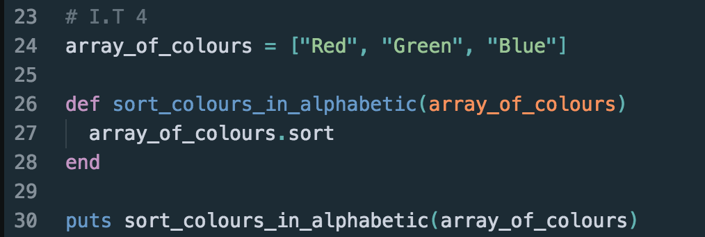

***Output***

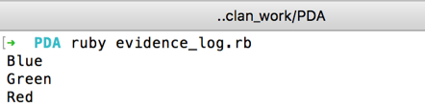

# REF I.T 5

***Input***

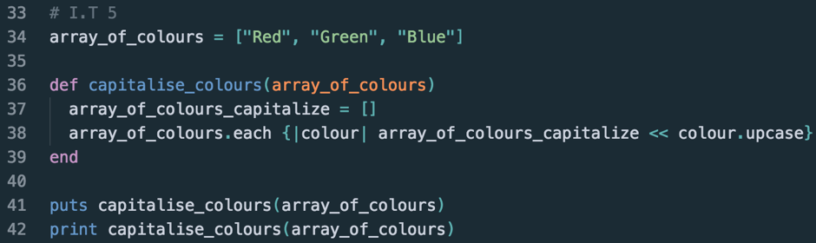

***Output***

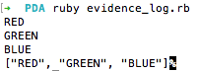

# REF I.T 6

***Input***

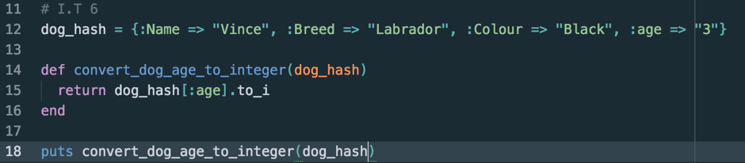

***Output***



# REF I.T 7

Interface

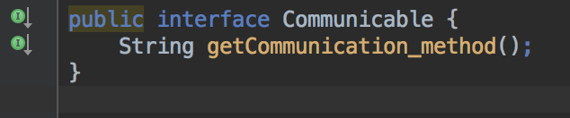

Class 1

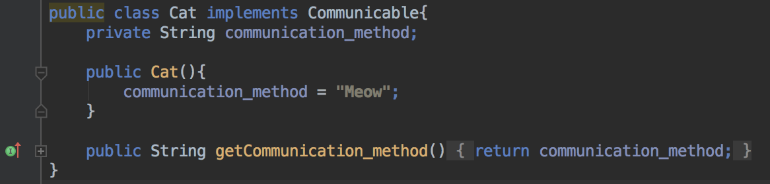

Class 2

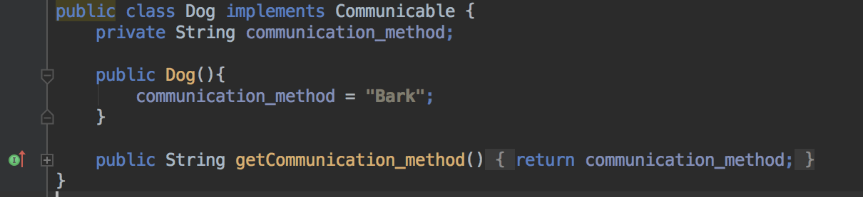

Class 3 using class 1 & 2

